

**UNITED INTERNATIONAL UNIVERSITY**

LAB REPORT-

Course Name: Control System Laboratory

Course Code: EEE 402/ EEE 4110 (A)

Submitted to;

RAHMAN, KALED MASUKUR

pROFESSOR

uiu

Submitted by;

Name: Joyanta Debnath

ID: 021-182-032

Date of Submission:

**EXP_01**: Matlab basics for Polynomial, Laplace Transform and Transfer Function.

**Objective**: Matlab’s basic tools allows us to perform symbolic mathematical computation using matlab. The only basic requirement is to declare symbolic variables before they are used. Our objectives toward this experiment;

* To be able to represent different systems; transfer function, poles and zeros and gain.
* To be able to represent one system to one system; specifically transfer function to poles zero to gain.
* To get the partial fraction expression.
* To be able to do laplace transform using Matlab.
* To be able to plot the poles and zeros of a transfer function.

**Part_A; Handling Polynomial in MATLAB** : The rational functions in the frequency domain will always be a ratio of polynomials, which have a very significant role to play in engineering systems analysis. Here we will elaborate uses of the functions ‘roots()’, ‘polyval()’, ‘conv()’, ‘deconv()’, ’tf()’ and ‘residue()’ .

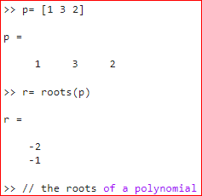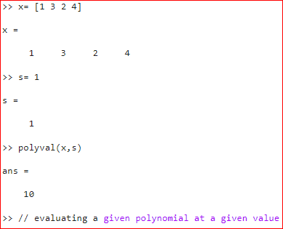

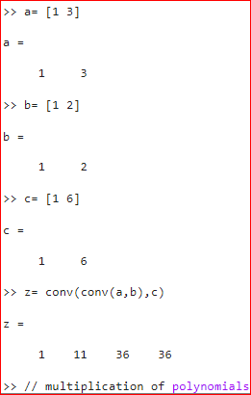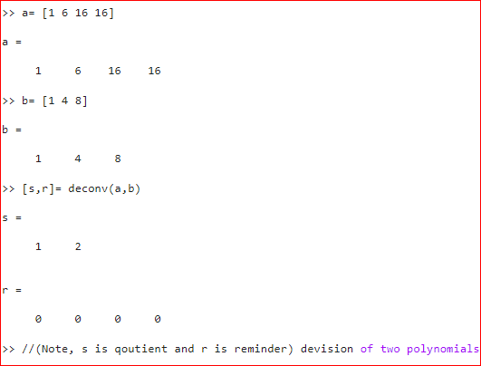

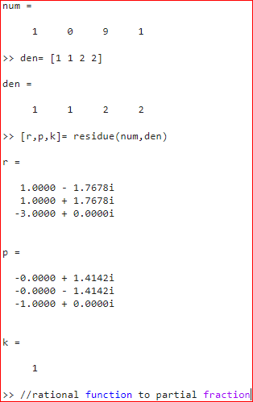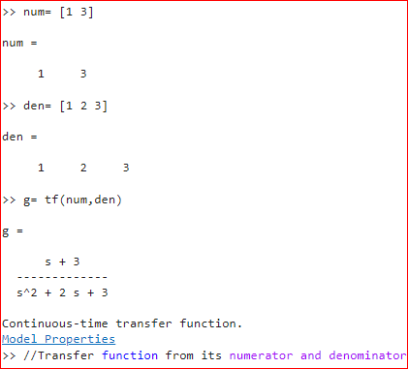

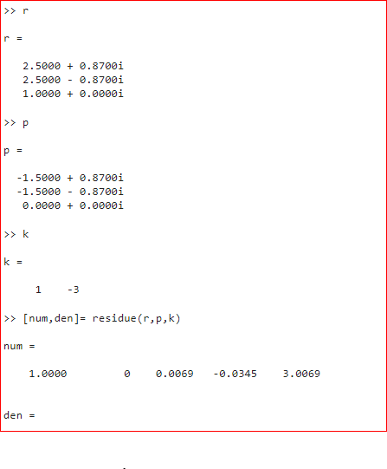

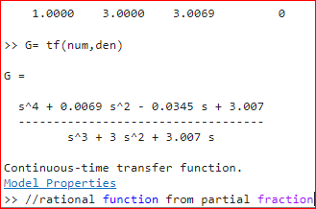

**Discussion**: From above analysis we achieved basics of polynomial by using Matlab tools. Thus, we can apply these knowledge in our further experiments.

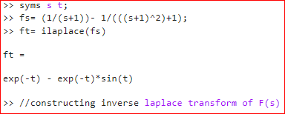**Part_B; Laplace transform using Matlab**: Laplace transform pairs are very useful tools for solving ordinary differential equations. Most applications involve signals that are exponential in the time domain and rational in the frequency domain. MATLAB provides tools for dealing with this class of signals. Our goal is to get acquainted with these tools and develop some familiarity on laplace transformation F(s) of a function f(t) and the inverse Laplace transform of a function F(s).

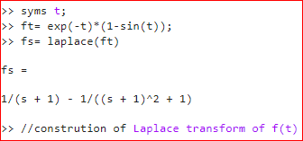

**Discussion**: With the help of basic Matlab tools, we can easily construct laplace transform from given f(t) and inverse laplace transform from given F(s).

**Part_C; Transfer function and pole-zero map:** A transfer function is a convenient way to represent a linear, time-invariant system in terms of its input-output relationship. Poles and Zeros of a transfer function are the frequencies for which the value of the denominator and numerator of transfer function becomes infinite and zero respectively.

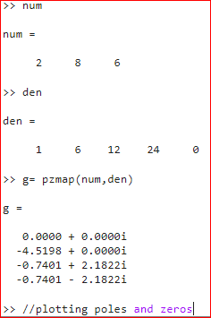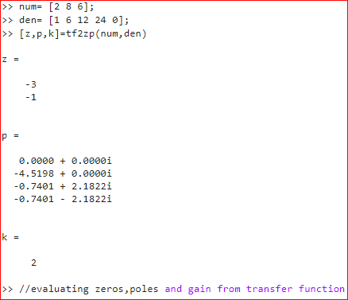

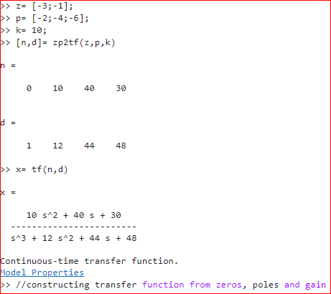

**Discussion**: With the help of basic Matlab tools, we can evaluate Zeros, Poles and Gain from given transfer function and also can plot them as well. Again, we can construct a transfer function from give zeros, poles and gain.

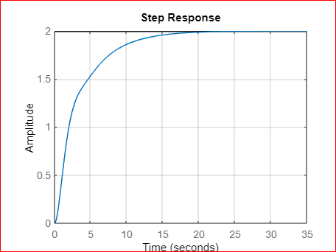**Part_D; Response of a system through transfer function:** A transfer function is defined as the following relation between the output and the input to the system. Therefore, the inverse Laplace transform of the Transfer function of a system is the unit impulse response of the system. This can be thought of as the response to a brief external disturbance. The system response is the output of the system when excited with the input. In simple words, how the organism reacts to a stimulus and results in a change in behavior.

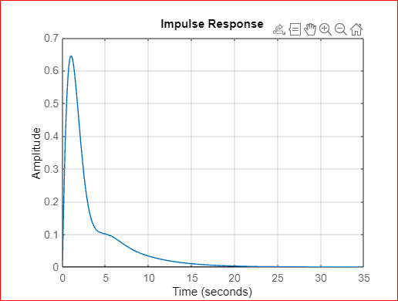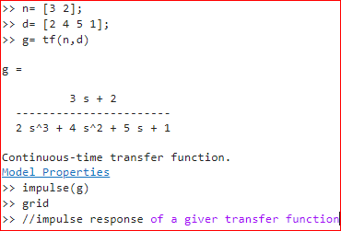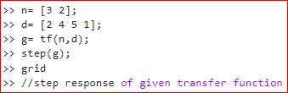

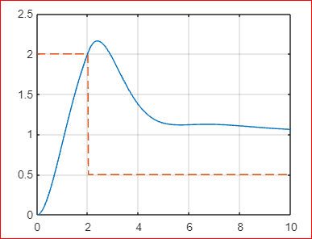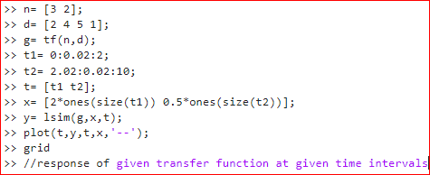

**Discussion**: With the help of basic Matlab tools, we evaluate and plot the systems response interims of given transfer function and time interval. We also evaluate the impulse and the step response of the given transfer function.

**Part_E; Homework:**

* 1. Matlab command to find the followings polynomial in simplified form;

1. (s + 2)(s + 7)(s3 + 1) ii. (****)**/**(s + 2)

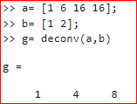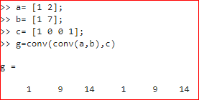

* 1. The Laplace transform of the following f(t) using MATLAB;

1. 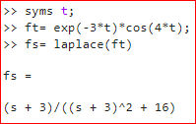f(t) =  ii. f(t) = 1-2e-4t +e-5t

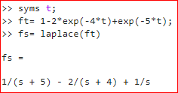

* 1. The inverse Laplace transform of the following F(s);

1. F(s) = (s^5 + 8 s^4 + 23 s^3 + 35 s^2 + 28 s + 3) / (s^3 + 6 s^2 + 8 s)

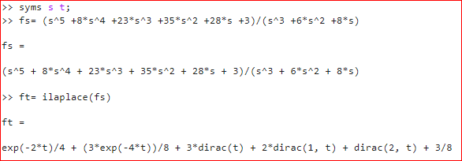

1. F(s) = [10(s + 2) (s +4)] / [( s + 1) (s + 3) (s + 5)2 ]

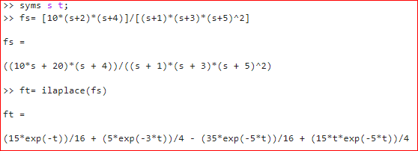

* 1. The zeros, poles and gain K, obtain the transfer function G(s);

1. 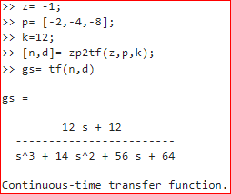A zero is at −1. Poles are at −2, −4 and −8. K = 12.
2. 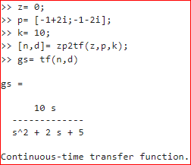A zero is at 0. Poles are at -1 + 2j and −1 − 2j. K = 10.

1.5 A plot of the ramp response of the system whose transfer function is shown below;

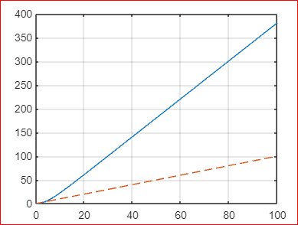

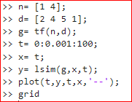

**Conclusion:** By utilizing MATLAB's capabilities for polynomials, Laplace transforms, and transfer functions, we can efficiently model, analyze, and design complex systems. MATLAB's extensive library of functions and tools, combined with its user-friendly interface, make it a versatile and powerful environment for working with these mathematical concepts. Overall, mastering MATLAB basics for polynomials, Laplace transforms, and transfer functions equips us with essential skills to tackle a wide range of engineering and scientific problems, and opens up opportunities for advanced analysis and control system design.